Present Value (PV)
The present value of the future $X: we need to find out how much we would have to invest today (current cash) in order to receive that $X in the future.
To find the present value of the future $10,000, we need to find out how much we would have to invest today (current value) in order to receive that $10,000 in the future.
Example1:
Find the PV of $2 million after 5 years from now where the Discount rate is 8%?
PV = 2 million/((1+.08)5) = $1,361,166

Net Present Value (NPV)

- NPV is the sum of the PVs over a period of time (T years) or NPV = Sum of PVs
    - PV year 0 + PV year 1 + PV year2 + PV year3 + … + PV year T

Formula:
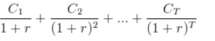
r: Discount rate , Ci: cash flow in year i

- Overall NPV = NPV (all benefits)- NPV (all Costs)
- Overall ROI = Overall NPV / NPV (Costs)

Example2:
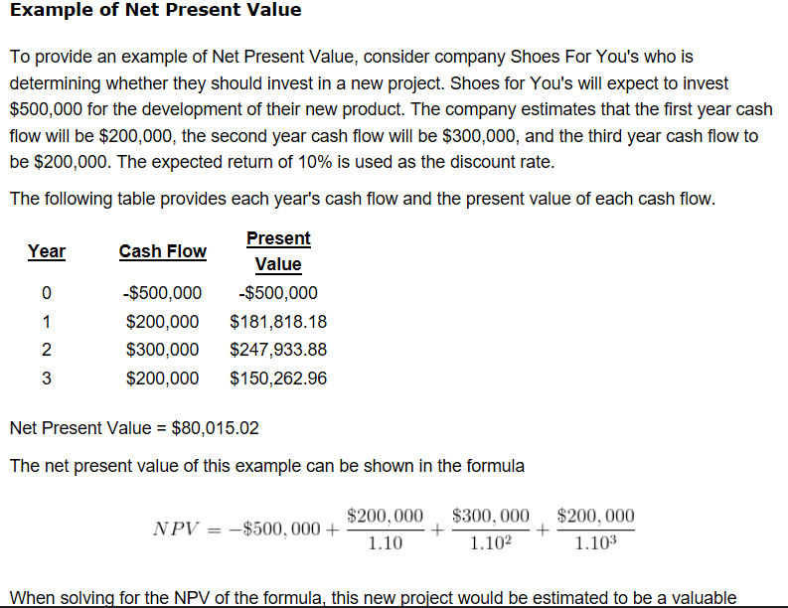

Example3: Consider the economic benefits and recurring cost of each year in the below figure and then find the overall NPV and overall ROI

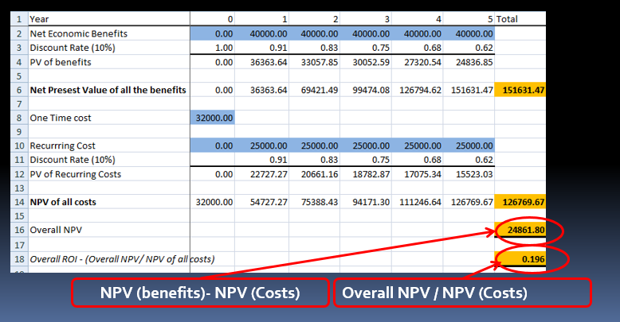

Break Even Analysis

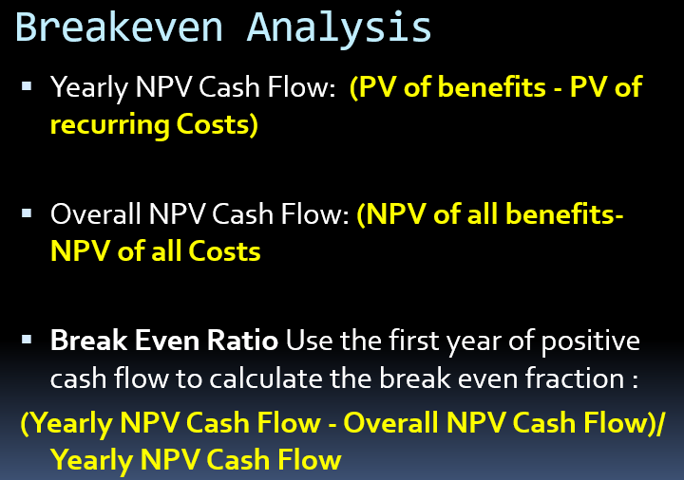

Example4: Calculate the Break Even Ratio for the data of Example 3.

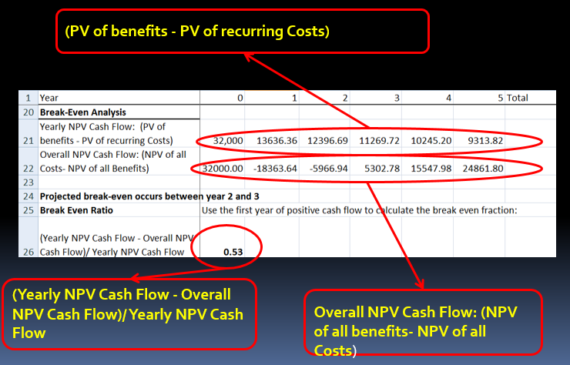

Return on Investment (ROI)
The return on investment formula:
ROI = (Gain from Investment - Cost of Investment) / Cost of Investment
- Gain from Investment represents the receipts
- Cost of Investment represents the outlays

Example5:
An investor purchases property A, which is valued at $500,000; two years later, the investor sells the property for $1,000,000.
We use the investment gain formula in this case.
ROI = (1,000,000 – 500,000) / (500,000) = 1 or 100%

